**What are three conclusions we can make about Kickstarter campaigns given the provided data?**

* Over the given time period the top 3 categories (in terms of attempts) were Theater, Music, and Film & Video.
* The categories with the most successes also followed the same order, with theater leading the pack.
* When looking at sub-categories, Plays account for 26% of the grand total. Who knew that plays were still a thing?
* The total number of kickstarters peaked in 2015. Since the data only includes a partial amount for 2017 it is difficult to say if the drop in 2016 (back to 2014 levels) indicates a downward trend or if it will continue upwards again.

**What are some of the limitations of this dataset?**

* Kickstarters can extend their deadlines once, it is unknown if this data set only includes the original deadline, or possibly extended deadlines.

**What are some other possible tables/graphs that we could create?**

* I was curious what the average duration was, based on start and deadline dates. It appears that initially the durations were higher and then over the course of 3 years they dropped into a 30-35 day range.

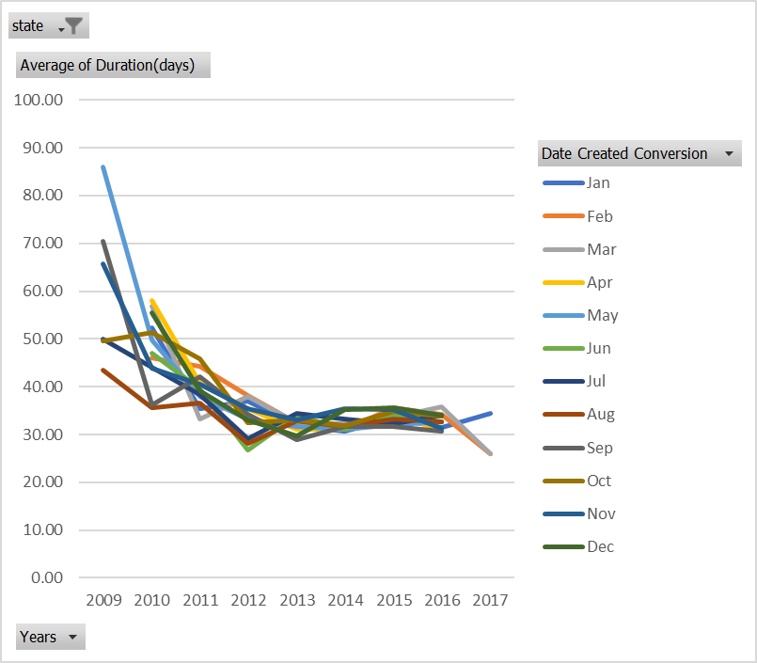

* 87% of the staff picks were successful

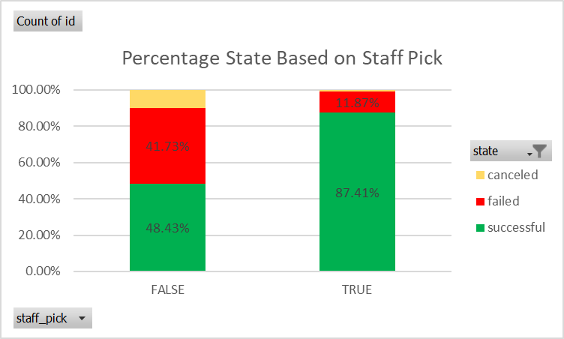

* But the staff only picked a little over 13% of the kickstarter pool.

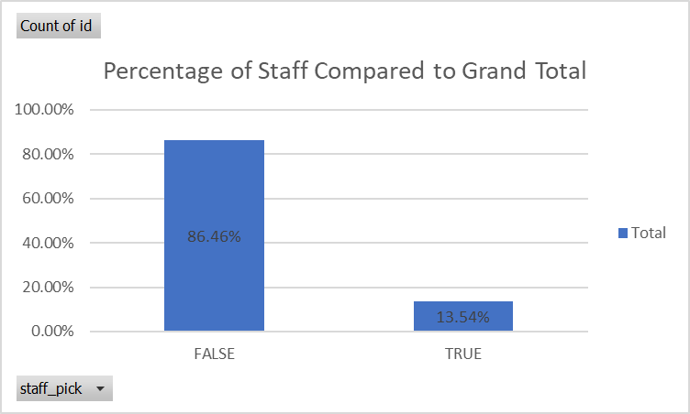

* Here’s a meaningless pie chart without labels for Brady.

